**Project Design Phase-II**

**Technology Stack (Architecture & Stack)**

|  |  |
| --- | --- |
| Date | 03 October 2022 |
| Team ID | PNT2022TMID45324 |
| Project Name | Smart Fashion Recommender Application |
| Maximum Marks | 4 Marks |

**Technical Architecture:**

The Deliverable shall include the architectural diagram as below and the information as per the table1 & table 2

**Example: Order processing during pandemics for offline mode**

**Reference:** [**https://miro.com/app/board/uXjVPCLPVco=/?share_link_id=685266313592**](https://miro.com/app/board/uXjVPCLPVco=/?share_link_id=685266313592)

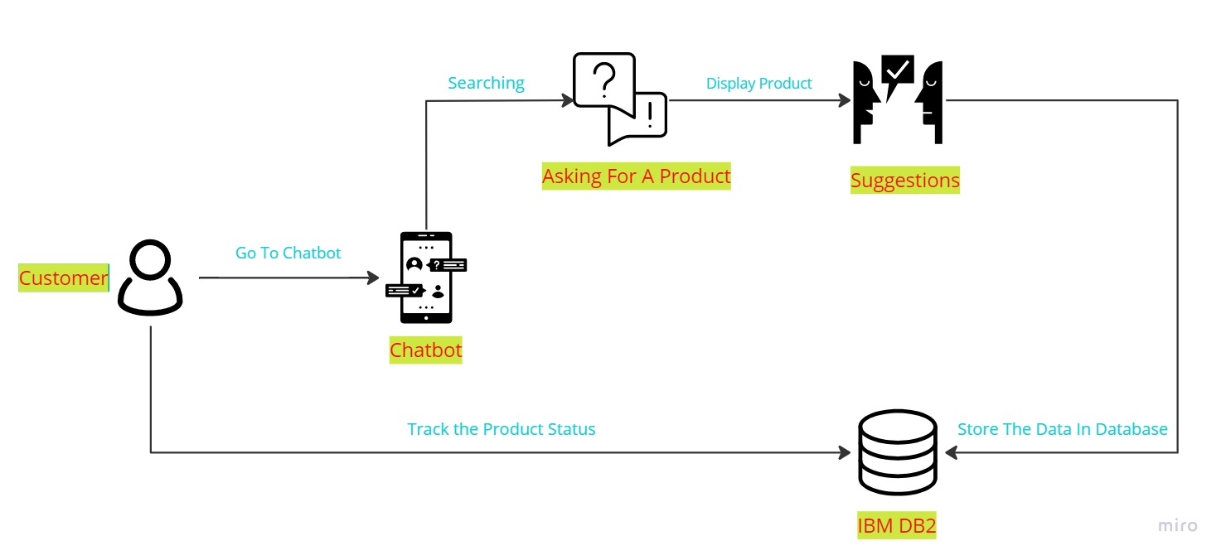

**Table-1 : Components & Technologies:**

|  |  |  |  |
| --- | --- | --- | --- |
| **S.No** | **Component** | **Description** | **Technology** |
|  | User Interface | How user interacts with application e.g.  Web UI, Mobile App, Chatbot etc. | HTML, CSS, JavaScript. |
|  | Login | The login Page accept the username and password | Python |
|  | SignUp | Signup page accept the username and password | Python |
|  | Dashboard | User Order | Html,css and javascript |
|  | Database | Localhost:8080 | SQL |
|  | Cloud Database | Database Service on Cloud | IBM DB2. |
|  | Object Storage | Project | IBM Object Storage |
|  | IBM Watson Assistance | User Order | IBM Watson API |
|  | Infrastructure (Server / Cloud) | Application Deployment on Local System / Cloud  Local Server Configuration:  Cloud Server Configuration : | Local, Cloud Foundry, Kubernetes, etc. |

**Table-2: Application Characteristics:**

|  |  |  |  |
| --- | --- | --- | --- |
| **S.No** | **Characteristics** | **Description** | **Technology** |
|  | Open-Source Frameworks | Flask | Python based Framework |
|  | Security Implementations | List all the security / access controls implemented, use of firewalls etc. | e.g. SHA-256, Encryptions, IAM Controls, OWASP etc. |
|  | Scalable Architecture | Justify the scalability of architecture (3 – tier, Micro-services) | Technology used |
|  | Availability | Justify the availability of application (e.g. use of load balancers, distributed servers etc.) | Technology used |
|  | Performance | Design consideration for the performance of the application (number of requests per sec, use of Cache, use of CDN’s) etc. | Technology used |

**References:**

[**https://c4model.com/**](https://c4model.com/)

[**https://developer.ibm.com/patterns/online-order-processing-system-during-pandemic/**](https://developer.ibm.com/patterns/online-order-processing-system-during-pandemic/)

[**https://www.ibm.com/cloud/architecture**](https://www.ibm.com/cloud/architecture)

[**https://aws.amazon.com/architecture**](https://aws.amazon.com/architecture)

[**https://medium.com/the-internal-startup/how-to-draw-useful-technical-architecture-diagrams-2d20c9fda90d**](https://medium.com/the-internal-startup/how-to-draw-useful-technical-architecture-diagrams-2d20c9fda90d)